 | READING 1  Week 40-44, 2021  Debate: week 45, 2021 | READING 2  Week 46-50, 2021  Debate: week 51, 2021 | READING 3  Week 52, 2021-week 4, 2022  Debate: week 5, 2022 | READING 4  Week 6-9, 2022  Debate: week 10, 2022 | READING 5  Week 11-15, 2022  Debate: week 16, 2022 | READING 6  Week 17-21, 2022  Debate: week 22, 2022
Title  Author | FOR HE CAN CREEP  Siobhan Carroll | 4:50 FROM PADDINGTON  Agatha Christie | THE CARD  Bennet Arnold | THE WILD BRIDE  Carl Grose, Emma Rice  (to be listened to) | NONSTOP  Tad Williams | LORD OF THE FLIES  William Golding
Cover | 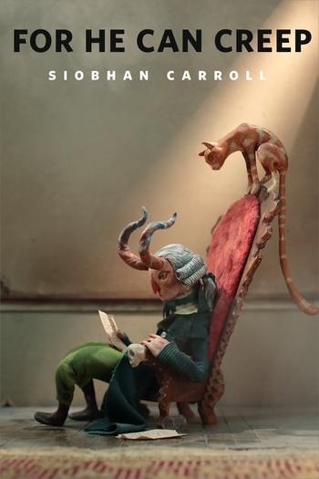 | 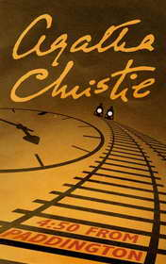 | 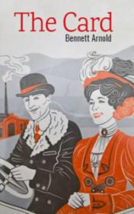 | 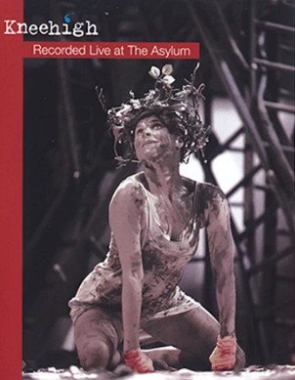 | 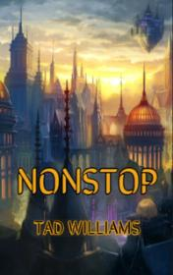 | 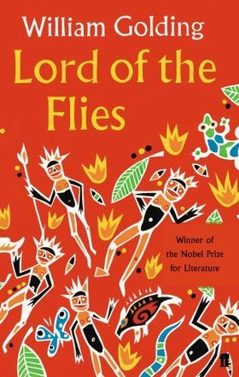
Genre | Dark fantasy novelette | Detective fiction novel | Novel | Dark blues musical fairy tale. (Radio drama) | Adventure | Dystopian novel
Annotation | Nineteenth century poet Christopher Smart has been committed to hospital for lunatics believing God wants him to write The Divine Poem. Years earlier, he made a bargain with Satan who has come to collect his poem that will bring about the apocalypse.  Saving Smart's soul, and the rest of the world, falls to Jeoffry, the poet's demon-fighting cat. | For an instant the two trains ran together, side by side. In that frozen moment, Elspeth witnessed a murder. Helplessly, she stared out of her carriage window as a man remorselessly tightened his grip around a woman’s throat. The body crumpled. Then the other train drew away. But who, apart from Miss Marple, would take her story seriously? After all, there were no suspects, no other witnesses… and no corpse. | If you want to become as successful as possible, what qualities will you need first of all? Will the smartest person be the most successful? Or good looks and charisma are the things you need? Perhaps hardworking people are able to get extremely successful. Are only luck, good looks and charisma important for success? Denry Machin never gives up. Of course, he is very lucky. But his methods of becoming rich are not entirely legal. | Down at the crossroads, the wind blows as the Devil sits in a rocking chair and tells a story. It's a tale of love and war, good and evil; the tale of a young girl, whose father accidentally sells her soul to the Devil. The girl chooses to walk into the wilderness. She rejects not only the Devil, but also her home and must survive the ravages of nature and time. | Henry hated to fly. Perhaps 'hate' is not a suitable word. Hate implies anger, some actions. But the flight on the plane filled Henry with such animal horror that he became completely helpless. The despair was so strong that other passengers noticed it. Even besides flying, there were many unpleasant moments in Henry's life. He was supposed to fly to Dallas with his wife, but she was not able to go with Henry due to problems at work. | When their plane crashes, 25 schoolboys find themselves trapped on an island, miles from civilization. At first, they welcome their new freedom. But soon they discover that trying to survive is anything but fun. They want to live according to the values of the civilization they left behind, but the attempt to govern themselves is disastrous.
Moderator | Marcel Kukuczka | Monika Kopecká | Monika Kopecká | Marcel Kukuczka | Monika Kopecká | Marcel Kukuczka
Level | B2+/C1/C2 (full text) | B2 Intermediate+ | B1+ Intermediate | B2+/C1/C2 (full text) | B1+ Intermediate | B2+/C1/C2 (full text)

 | READING 1 | READING 2 | READING 3 | READING 4 | READING 5 | READING 5
Days for reading | 4 Oct – 7 Nov 2021 | 15 Nov – 19 Dec 2021 | 27 Dec 2021 – 30 Jan 2022 | 7 Feb – 6 Mar 2022 | 14 Mar – 17 Apr 2022 | 25 Apr – 29 May 2022
Discussion day | 8 – 12 Nov 2021 (upon agreement) | 20 – 22 Dec 2021  (upon agreement) | 31 Jan – 3 Feb 2022  (upon agreement) | 7 – 11 Mar 2022  (upon agreement) | 19 – 22 Apr 2022  (upon agreement) | 30 May – 3 Jul 2022  (upon agreement)

READING 1 | FOR HE CAN CREEP  Siobhan Carroll | Available at:  Free: https://www.tor.com/2019/07/10/for-he-can-creep-siobhan-carroll/  Paid (around $1): Kindle Store, Apple Books, Barnes&Noble, Kobo Books | Downloadable formats:  web, mobi, ePub
READING 2 | 4:50 FROM PADDINGTON  Agatha Christie | Available at:  Free: https://english-e-reader.net/book/450-from-paddington-agatha-christie | Downloadable formats:  ePub, mobi, fb2, rtf, txt, mp3
READING 3 | THE CARD  Bennet Arnold | Available at:  Free: https://english-e-reader.net/book/the-card-bennet-arnold | Downloadable formats:  ePub, mobi, fb2, rtf, txt, mp3
READING 4 | THE WILD BRIDE  Carl Grose, Emma Rice  (to be listened to) | Available at:  An mp3 file will be provided free (for study purposes only) by the moderator. | Downloadable formats:  mp3
READING 5 | NONSTOP  Tad Williams | Available at:  Free: https://english-e-reader.net/book/nonstop-tad-williams | Downloadable formats:  ePub, mobi, fb2, rtf, txt, mp3
READING 6 | LORD OF THE FLIES  William Golding | Available at:  Free: http://kkoworld.com/kitablar/uilyam_qoldinq_milchekler_krali-eng.pdf  Paid (around $10): Kindle Store, Apple Books, Barnes&Noble, Kobo Books | Downloadable formats:  pdf, mobi, ePub

